**TODAS LAS MEDIDAS ESTÁN EN MM**

**ESLABÓN 1**

Mass properties of selected components

Coordinate system: Coordinate System1

The center of mass and the moments of inertia are output in the coordinate system of Ensamble Dedo

Mass = 44.96 grams

Volume = 29031.22 cubic millimeters

Surface area = 11385.37 square millimeters

Center of mass: ( millimeters )

X = 10.68

Y = 8.68

Z = 55.23

Principal axes of inertia and principal moments of inertia: ( grams * square millimeters )

Taken at the center of mass.

Ix = ( 0.29, 0.01, 0.96) Px = 8671.04

Iy = (-0.46, -0.87, 0.15) Py = 90579.62

Iz = ( 0.84, -0.49, -0.25) Pz = 96105.36

Moments of inertia: ( grams * square millimeters )

Taken at the center of mass and aligned with the output coordinate system.

Lxx = 87358.12 Lxy = 2465.66 Lxz = 24175.84

Lyx = 2465.66 Lyy = 91892.08 Lyz = 4.59

Lzx = 24175.84 Lzy = 4.59 Lzz = 16105.82

Moments of inertia: ( grams * square millimeters )

Taken at the output coordinate system.

Ixx = 227887.96 Ixy = 6635.35 Ixz = 50697.82

Iyx = 6635.35 Iyy = 234161.39 Iyz = 21565.30

Izx = 50697.82 Izy = 21565.30 Izz = 24624.70

**ESLABÓN 2**

Mass properties of selected components

Coordinate system: Coordinate System2

The center of mass and the moments of inertia are output in the coordinate system of Ensamble Dedo

Mass = 20.39 grams

Volume = 12462.45 cubic millimeters

Surface area = 5831.64 square millimeters

Center of mass: ( millimeters )

X = -22.43

Y = 0.00

Z = 15.81

Principal axes of inertia and principal moments of inertia: ( grams * square millimeters )

Taken at the center of mass.

Ix = ( 0.83, 0.00, -0.56) Px = 776.05

Iy = ( 0.00, 1.00, 0.00) Py = 3612.62

Iz = ( 0.56, 0.00, 0.83) Pz = 3691.29

Moments of inertia: ( grams * square millimeters )

Taken at the center of mass and aligned with the output coordinate system.

Lxx = 1705.35 Lxy = 0.00 Lxz = -1358.50

Lyx = 0.00 Lyy = 3612.62 Lyz = 0.00

Lzx = -1358.50 Lzy = 0.00 Lzz = 2761.98

Moments of inertia: ( grams * square millimeters )

Taken at the output coordinate system.

Ixx = 6798.75 Ixy = -0.01 Ixz = -8587.23

Iyx = -0.01 Iyy = 18965.28 Iyz = 0.00

Izx = -8587.23 Izy = 0.00 Izz = 13021.26

**ESLABÓN 3**

Mass properties of 3

Configuration: Predeterminado

Coordinate system: Coordinate System3

The center of mass and the moments of inertia are output in the coordinate system of Ensamble Dedo

Density = 0.00 grams per cubic millimeter

Mass = 3.34 grams

Volume = 3272.38 cubic millimeters

Surface area = 1487.24 square millimeters

Center of mass: ( millimeters )

X = -10.26

Y = 0.00

Z = 9.22

Principal axes of inertia and principal moments of inertia: ( grams * square millimeters )

Taken at the center of mass.

Ix = (-0.52, 0.00, 0.85) Px = 83.28

Iy = ( 0.85, 0.00, 0.52) Py = 193.72

Iz = ( 0.00, 1.00, 0.00) Pz = 222.87

Moments of inertia: ( grams * square millimeters )

Taken at the center of mass and aligned with the output coordinate system.

Lxx = 163.78 Lxy = 0.00 Lxz = -49.09

Lyx = 0.00 Lyy = 222.87 Lyz = 0.00

Lzx = -49.09 Lzy = 0.00 Lzz = 113.23

Moments of inertia: ( grams * square millimeters )

Taken at the output coordinate system.

Ixx = 447.83 Ixy = 0.00 Ixz = -364.86

Iyx = 0.00 Iyy = 857.95 Iyz = 0.00

Izx = -364.86 Izy = 0.00 Izz = 464.26

**ESLABÓN 4**

Mass properties of selected components

Coordinate system: Coordinate System4

The center of mass and the moments of inertia are output in the coordinate system of Ensamble Dedo

Mass = 28.90 grams

Volume = 13282.56 cubic millimeters

Surface area = 6575.60 square millimeters

Center of mass: ( millimeters )

X = -5.84

Y = -0.01

Z = 23.11

Principal axes of inertia and principal moments of inertia: ( grams * square millimeters )

Taken at the center of mass.

Ix = (-0.45, 0.00, 0.89) Px = 1459.97

Iy = ( 0.89, 0.00, 0.45) Py = 9483.52

Iz = ( 0.00, 1.00, 0.00) Pz = 9835.11

Moments of inertia: ( grams * square millimeters )

Taken at the center of mass and aligned with the output coordinate system.

Lxx = 7832.41 Lxy = -0.60 Lxz = -3243.70

Lyx = -0.60 Lyy = 9835.11 Lyz = 0.64

Lzx = -3243.70 Lzy = 0.64 Lzz = 3111.08

Moments of inertia: ( grams * square millimeters )

Taken at the output coordinate system.

Ixx = 23267.39 Ixy = 0.49 Ixz = -7147.13

Iyx = 0.49 Iyy = 26257.25 Iyz = -3.68

Izx = -7147.13 Izy = -3.68 Izz = 4098.24

**ESLABÓN 5**

Mass properties of selected components

Coordinate system: Coordinate System5

The center of mass and the moments of inertia are output in the coordinate system of Ensamble Dedo

Mass = 10.88 grams

Volume = 3139.98 cubic millimeters

Surface area = 2116.77 square millimeters

Center of mass: ( millimeters )

X = -0.06

Y = 12.47

Z = 5.69

Principal axes of inertia and principal moments of inertia: ( grams * square millimeters )

Taken at the center of mass.

Ix = ( 0.02, 0.99, 0.13) Px = 230.50

Iy = (-0.06, -0.12, 0.99) Py = 570.67

Iz = ( 1.00, -0.03, 0.05) Pz = 616.55

Moments of inertia: ( grams * square millimeters )

Taken at the center of mass and aligned with the output coordinate system.

Lxx = 616.21 Lxy = 8.79 Lxz = -1.49

Lyx = 8.79 Lyy = 236.03 Lyz = 42.29

Lzx = -1.49 Lzy = 42.29 Lzz = 565.47

Moments of inertia: ( grams * square millimeters )

Taken at the output coordinate system.

Ixx = 2659.78 Ixy = 0.00 Ixz = -5.49

Iyx = 0.00 Iyy = 587.84 Iyz = 813.73

Izx = -5.49 Izy = 813.73 Izz = 2257.32

**ESLABÓN 6**

Mass properties of 6

Configuration: Predeterminado

Coordinate system: Coordinate System6

The center of mass and the moments of inertia are output in the coordinate system of Ensamble Dedo

Density = 0.00 grams per cubic millimeter

Mass = 7.27 grams

Volume = 5190.97 cubic millimeters

Surface area = 5139.21 square millimeters

Center of mass: ( millimeters )

X = -9.99

Y = 0.00

Z = 18.39

Principal axes of inertia and principal moments of inertia: ( grams * square millimeters )

Taken at the center of mass.

Ix = ( 0.85, 0.00, -0.52) Px = 871.95

Iy = ( 0.00, 1.00, 0.00) Py = 1017.52

Iz = ( 0.52, 0.00, 0.85) Pz = 1072.12

Moments of inertia: ( grams * square millimeters )

Taken at the center of mass and aligned with the output coordinate system.

Lxx = 925.87 Lxy = 0.00 Lxz = -88.81

Lyx = 0.00 Lyy = 1017.52 Lyz = 0.00

Lzx = -88.81 Lzy = 0.00 Lzz = 1018.20

Moments of inertia: ( grams * square millimeters )

Taken at the output coordinate system.

Ixx = 3383.30 Ixy = 0.00 Ixz = -1424.48

Iyx = 0.00 Iyy = 4200.92 Iyz = 0.00

Izx = -1424.48 Izy = 0.00 Izz = 1744.17

**REFERENCIALES NO INERCIALES**

$\sum_{1}^{2}{}$

Delta X: 32.36mm

Delta Y: 0.00mm

Delta Z: 105.13mm

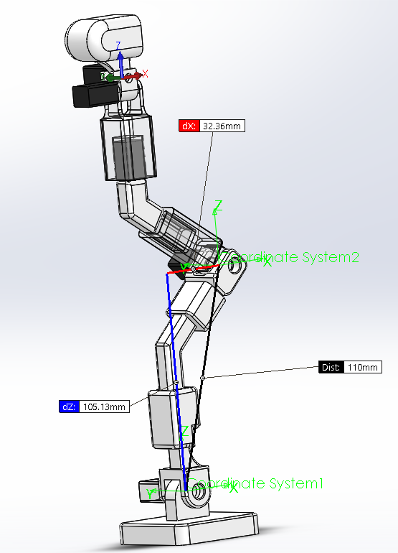

$\sum_{2}^{3}{}$

Delta X: 36.14mm

Delta Y: 0.00mm

Delta Z: 25.04mm

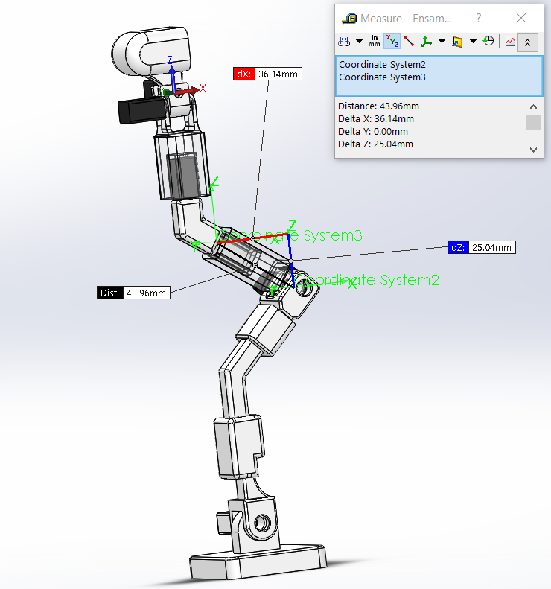

$\sum_{3}^{4}{}$

Delta X: 13.01mm

Delta Y: 0.00mm

Delta Z: 22.87mm

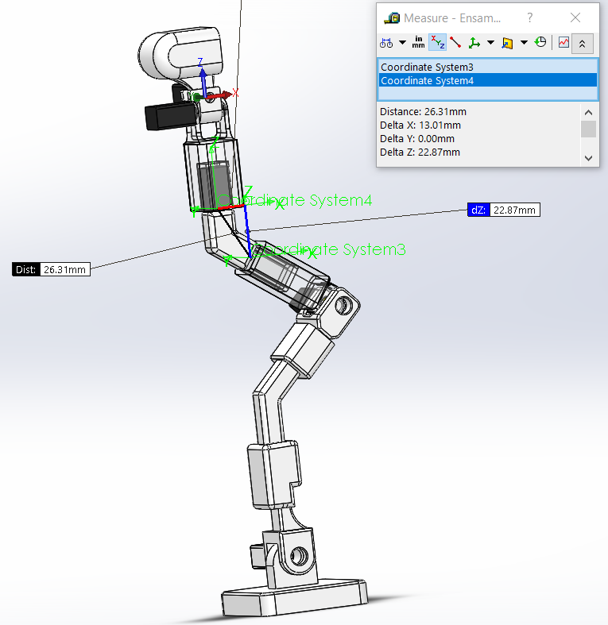

$\sum_{4}^{5}{}$

Delta X: 0.18mm

Delta Y: 0.00mm

Delta Z: 42.34mm

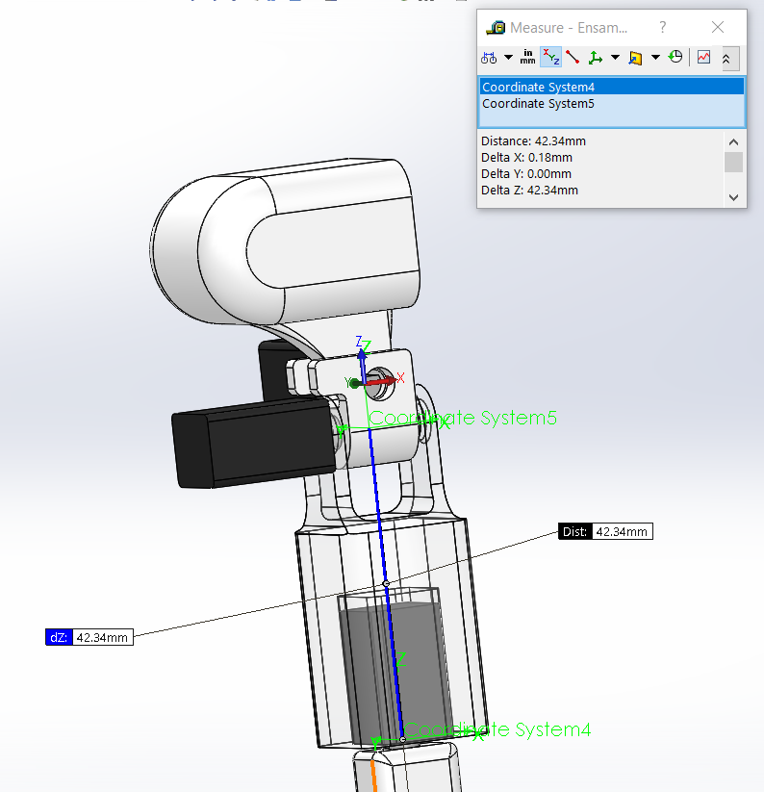

$$\sum_{5}^{6}{}$$

Delta X: 0.00mm

Delta Y: 0.00mm

Delta Z: 6.00mm

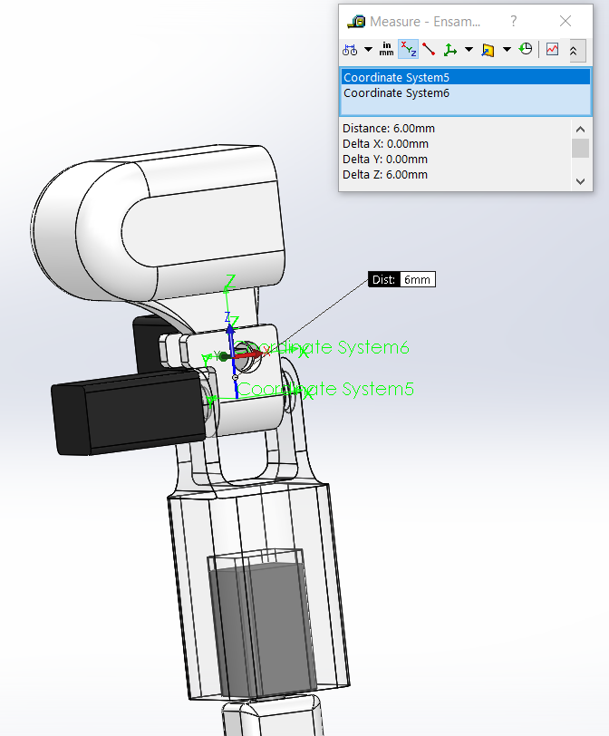

$$\sum_{6}^{7}{}$$

Delta X: 25.65mm

Delta Y: 0.00mm

Delta Z: 19.99mm

